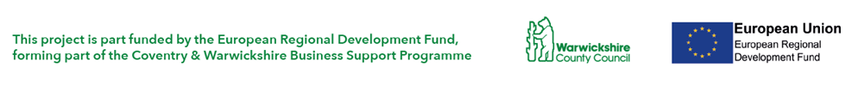****

**Raising Finance for Business**

**Venue: Binley Innovation Centre, Harry Weston Road, Binley, Coventry CV3 2TX**

**When: 29th March, 9.00-12.30**

Businesses looking to grow will usually need to raise finance to enable business growth.

* Do you want to understand different funding options for different types of business?
* Are you based in Coventry & Warwickshire and a small business looking to grow?
* Would you like to know about potential grant funding available?
* Would you like to know how to write a good funding application?
* Do you want independent advice from Funding specialists?
* Are you looking to raise at least £10,000 to grow your business?
* Are you a technology based or innovative business?

If so, the following workshop could be for you. This comprehensive workshop will help you to understand what type of funds are most appropriate for your business and how best to access those funds – learning from specialists in their field. There will be plenty of time for questions.

**Booking:**[**https://www.eventbrite.co.uk/e/raising-finance-for-business-binley-coventry-tickets-31485686536**](https://www.eventbrite.co.uk/e/raising-finance-for-business-binley-coventry-tickets-31485686536) **or contact** [**businessready@uwsp.co.uk**](mailto:businessready@uwsp.co.uk) **or 024 7632 3121**

|  |  |
| --- | --- |
| 9.00 | Registration and networking |
| 9.30 | Welcome and overview of business support in C&W |
| 9.45 | Introductions and objectives for the session |
| 10.00 | Getting the right funds for you – Grants, Equity, Debt, R&D Tax credits |
| 10.15 | Preparing for finance |
| 10.25 | Grant funding and applications |
| 11.00 | Refreshment break |
| 11.15 | Equity investments and investor requirements |
| 11.30 | Debt Finance options and funders requirements |
| 11.50 | Crowd Funding overview |
| 12.10 | Q &A and feedback |
| 12.30 | Feedback and Close |
|  | Optional tour of the facilities |

This practical workshop is managed by the Access to Finance specialists at University of Warwick Science Park, in partnership with other local business support providers. The Business Ready programme is part funded by the European Regional Development Fund, forming part of the Coventry & Warwickshire Business Support Programme.

08

**Fall**